Version information:
Version REV2025
Date: 08/05/2025
MLKPAI-FMin01 Hardware User Manual WeChat Scan Code to register for Milian Technology Forum www.uisrc.com enjoy more resources for free

Scan the code to follow the WeChat public platform "MILIANKE" to learn more information

Technical support
Customers can obtain the customer service contact information of the official Milian Ke store through the following link, join the Milian Ke Enterprise WeChat technical support group, and get professional technical support and answers. Thank you for your support!
JD Milian Ke flagship store:https://milianke.jd.com Tmall Milian Ke flagship store:https://milianke.tmall.com
Taobao Milian Ke Ecological Store:https://milianke.taobao.com
After-sales
1: 7 days for no reason to return (except for human reasons).
2: Warranty period: Our products provide one-year warranty service from the date of express delivery (except for main chips, such as FPGAs or CPUs).
3: For repair and exchange, you need to provide the Taobao order number or contract number, and contact sales/technical support to arrange the return.
For after-sales maintenance, please log in to the work order system: https://www.uisrc.com/plugin.php?id=x7ree_service
4: The following situations are not covered by warranty
A: Damage to the board caused by improper use by users: such as short circuit of the development board caused by excessive voltage, solder pad falling off caused by self-soldering, peeling of copper wires, etc.
B: Improper daily maintenance of the user causes damage to the board: such as improper placement leading to corrosion of the circuit board, cracks in the substrate, etc
5: For products outside the scope of warranty (Article 4 above) and outside the warranty period, our company provides paid maintenance services. The maintenance only charges the cost of device materials, and the round-trip freight is all borne by the customer.
6: Return address, log in to the website to get the latest after-sales address:https://www.uisrc.com/t-1982.html
Changzhou Milianke Information Technology Co., Ltd. All rights reserved
Changzhou Liyang Headquarters: Building 10-1, Yachuang Hi-Tech Manufacturing Valley, Wutandu Road, Zhongguancun, Liyang City, Changzhou Nanjing R&D Base: Liandong U Valley, No. 3118, Jiyin Avenue, Moling Street, Jiangning District, Nanjing Nanjing Jiulong Lake Intelligent Manufacturing Innovation Port Building 3, 9th floor

version | Time | description
Rev2025 | 2025-08-05 | First edition

directory
1 Overall overview................................................................................................................................................................................. 5 2 Overview of hardware parameters......................................................................................................................................................................... 5 3 Integrated board .................................................................................................................................................................................... 6
4 Hardware Detailed Description........................................................................................................................................................................ 7 1：SF1 SOC ....................................................................................................................................................................... 7 2：FLASH ......................................................................................................................................................................... 7 3：UART ........................................................................................................................................................................... 8 4：JTAG ............................................................................................................................................................................ 8
5：DVP .............................................................................................................................................................................. 9 6: Buzzer, keys, DIP switch and LED ............................................................................................................................ 11
7：HDMI .......................................................................................................................................................................... 12 8: TF card slot ....................................................................................................................................................................... 13 9：EEPROM&RTC ......................................................................................................................................................... 13 10:25MHz crystal oscillator. ............................................................................................................................................................. 14
11: CEP interface ................................................................................................................................................................... 14 5 EG4S20NG88 IO Multiplexing Table.................................................................................................................................................... 16 6 Power Management.............................................................................................................................................................................. 18
7 Naming conventions............................................................................................................................................................................... 19 1: Core module naming conventions.................................................................................................................................................... 19
2: Development platform naming rules.................................................................................................................................................... 19
User Notice - Must See
Core board users: Hello! Thank you for using our products, in order to avoid problems during the development process, please read the following points before use.
- The hardware manual explains the parameters of the development board from the schematic diagram of the development board, if you have any questions, please check the schematic or contact sales, technical support.
- Please use a regulated power supply for power, not a power supply with a large ripple.
- Please do not make changes to the components on the core board, and contact customer service or technical support if necessary.
- If you do not contact customer service or technical support, you will make changes to the development board, causing damage to the development board, which is not covered by the warranty and must be borne by the user.
Changzhou Milianke Information Technology Co., Ltd
Technical Service Department

1 Overall overview
The MLKPAI-FMin01 launched by Milianke will lead most of the user IO of Anlu Technology's EG4S20NG88 chip, and the development board is small and has good scalability, and the pin spacing of the development board is designed to be directly installed on the breadboard to facilitate users to expand the module by themselves. FMin01's JTAG download, UART communication and power supply are all integrated on TYPE-C, realizing that a TYPE-C line can achieve two functions of power supply and communication, which greatly saves space.

2 Overview of hardware parameters
Overview of the hardware parameters of MLKPAI-FMin01
Main chip model | EG4S20NG88
Flash | W25Q16DVSN:16M-bit/2M-byte
UART&JTAG | Shared TYPE-C interface
DVP interface | Multiplexed with the derived user IO, it is compatible with the MLK-CAM004 camera module
Buzzer, buttons, DIP switch and LEDs | Passive buzzer, independent buttons x2, four-position DIP switch, LEDx8
HDMI output | Support 720P/60FPS
TF card slot | Support TF card slot for data storage
EEPROM | 2K-bit
RTC | A backup power supply can be used via the pin header that leads out
Crystal vibration | 25MHz on a single end
CEP | There are a total of 40 user IOs that lead to users on both channels
Power supply | USB 5V power supply
Dimensions | 26x62mm, can be plugged directly into the breadboard

3 Integrated board
Front:
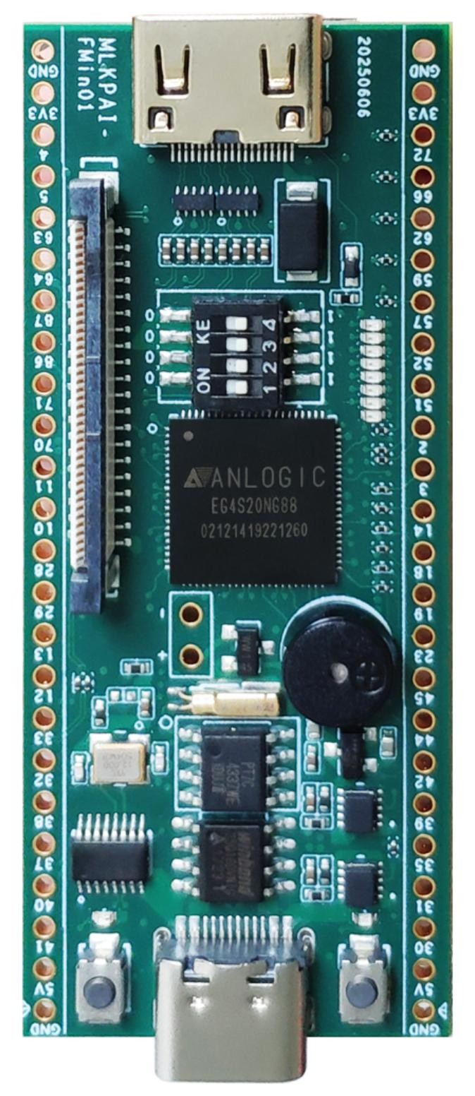
Reverse side:
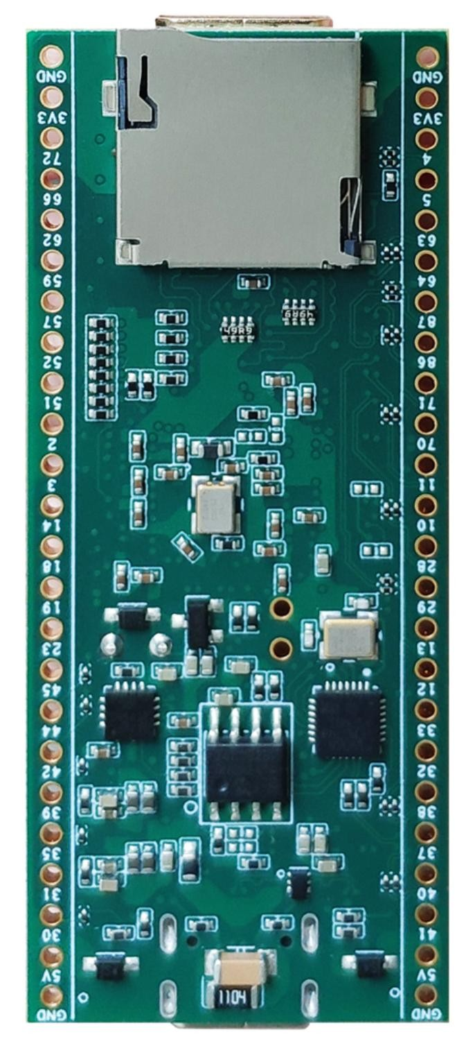

4 Hardware Detailed Description

1：SF1SOC
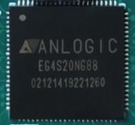
EG4S20NG88 chip parameters
LUTs | 19600
FFs | 19600
Dis-Ram bits | 156800
ERAM(9K) | 64
ERAM(32K) | 16
M18x18 | 29
SRAM | 4988928
PLL | 4
Low-skew GCLK | 16
EM SDRAM | 2Mx32bits
User IO Banks | 8
Maximum User IOs | 71
MLKPAI-FMin01 is equipped with an Anlu programmable SOC chip EG4S20NG88. The chip integrates 2Mx32bit SDRAM (EM638325), with a maximum operating frequency of 200Mhz and a maximum read and write bandwidth of up to 800MB/s.

2：FLASH
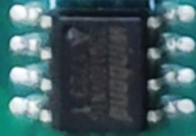
SPI FLASH, model W25Q16DVSN, can be used to save data and code. Main technical parameters: 16Mbit
•Standard SPIs: CLK, /CS, DI, DO, /WP, /Hold
•Clock rate: 104MHz
•Operating voltage: 3.3V
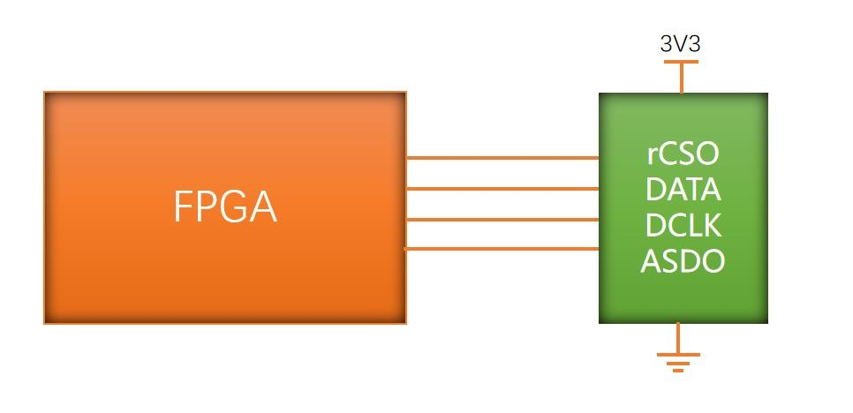
FLASH Pin Assignment Table:
Signal name | FPGA PIN | IOSTANDARD |  | description
AS_rCSO | 69 | LVCOMS33 | Film selection
AS_DATA | 80 | LVCOMS33 | The main collection and issuance
AS_DCLK | 82 | LVCOMS33 | clock
AS_ASDO | 81 | LVCOMS33 | The main issue is followed by collection

3：UART
In order to integrate with JTAG on the same TYPE-C interface, MLKPAI-FMin01 is equipped with a USB hub chip, and at the same time, a USB conversion chip is used to realize the FPGA to communicate with the outside world through the serial port.
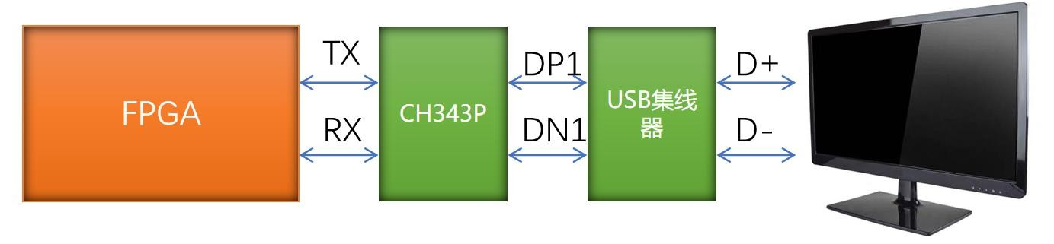
UART Pin Assignment Table:
Signal name | FPGA PIN | IOSTANDARD | description
FPGA_UART_TXD | 17 | LVCOMS33 | FPGA UART serial port send
FPGA_UART_RXD | 16 | LVCOMS33 | FPGA UART serial port reception

4：JTAG
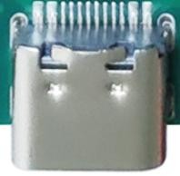
In order to integrate with UART on the same TYPE-C interface, MLKPAI-FMin01 integrates the Anlu low-speed downloader solution, which can be compiled and debugged by the compiler launched by Anlu through the data cable, and the TYPE-C data cable is also the total power supply for power supply, saving cables.
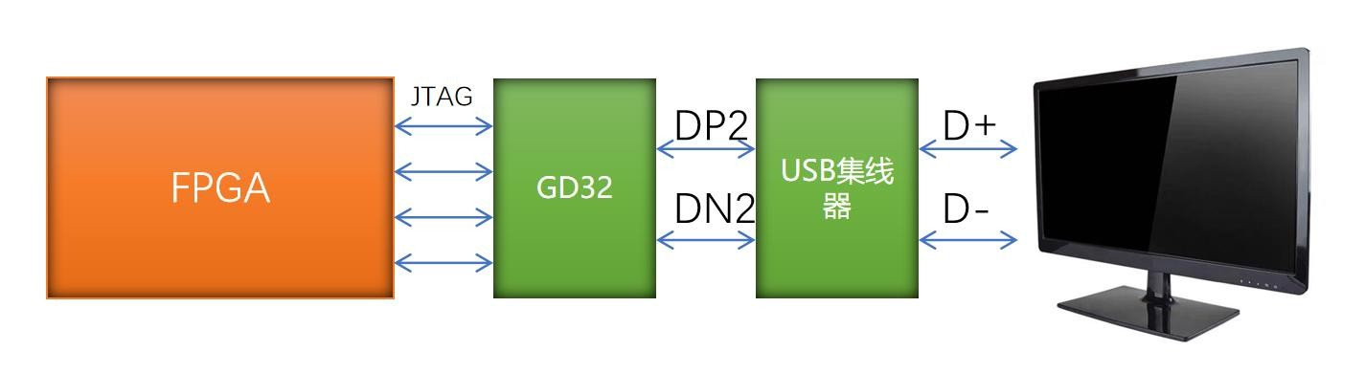
JTAG Pin Assignment Table:
Signal name | FPGA PIN | IOSTANDARD |  | description
JTAG_TMS | 22 | LVCOMS33 | JTAG interface
JTAG_TCK | 26 | LVCOMS33 | JTAG interface
JTAG_TDO | 21 | LVCOMS33 | JTAG interface
JTAG_TDI | 25 | LVCOMS33 | JTAG interface

5：DVP
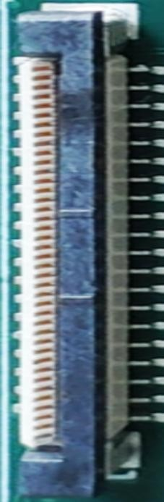
The MLKPAI-FMin01 leads the DVP interface and can be adapted to the MLK-CAM004 camera module. The DVP interface leads the signal line to be fully multiplexed with the J4 headers.
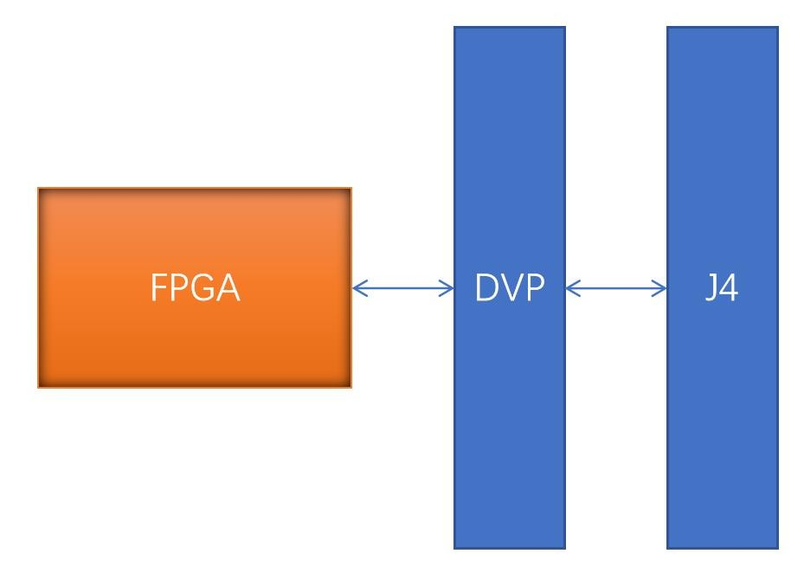
DVP Pin Assignment Table:
DVP PIN |  | FPGA PIN | IOSTANDARD
1 | VCC_3V3 | \ | \
2 | VCC_3V3 | \ | \
3 | B4_BE2N_40 | 40 | LVCOMS33

4 | B4_BE2P_41 | 41 | LVCOMS33
5 | B4_BE1P_37 | 37 | LVCOMS33
6 | B4_BE1N_38 | 38 | LVCOMS33
7 | GND | \ | \
8 | \ | \ | \
9 | \ | \ | \
10 | GND | \ | \
11 | \ | \ | \
12 | \ | \ | \
13 | B3_BE2N_33 | 33 | LVCOMS33
14 | B3_BE2P_32 | 32 | LVCOMS33
15 | GND | \ | \
16 | \ | \ | \
17 | \ | \ | \
18 | B3_BE1N_28 | 28 | LVCOMS33
19 | B3_BE1P_29 | 29 | LVCOMS33
20 | GND | \ | \
21 | B1_L2P_10 | 10 | LVCOMS33
22 | B1_L2N_11 | 11 | LVCOMS33
23 | B1_L3P_12 | 12 | LVCOMS33
24 | B1_L3N_13 | 13 | LVCOMS33
25 | GND | \
26 | B8_TE1N_87 | 87 | LVCOMS33
27 | B8_TE1P_86 | 86 | LVCOMS33
28 | B7_TE1P_70 | 70 | LVCOMS33
29 | B7_TE1N_71 | 71 | LVCOMS33
30 | GND | \ | \
31 | \ | \ | \
32 | \ | \ | \
33 | B6_R2P_64 | 64 | LVCOMS33
34 | B6_R2N_63 | 63 | LVCOMS33
35 | \ | \ | \
36 | \ | \ | \
37 | B1_L1P_5 | 5 | LVCOMS33
38 | B1_L1N_4 | 4 | LVCOMS33
39 | \ | \ | \
40 | \ | \ | \

6: Buzzer, buttons, dip switch and LED
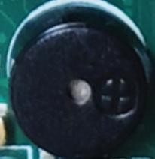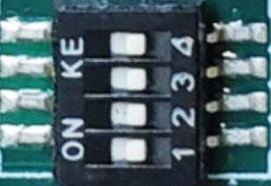
The MLKPAI-FMin01 integrates 8 LED red lights, a passive buzzer, a four-position DIP switch, and two buttons.
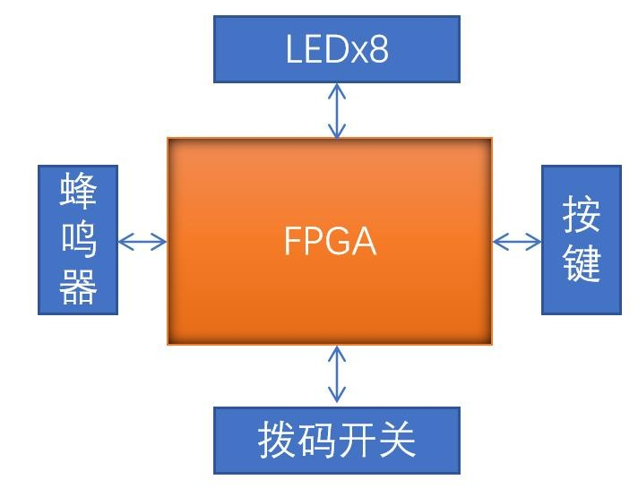
LED Pin Distribution Table:
Signal name | FPGA PIN | IOSTANDARD
B1_L4_14 | 14 | LVCOMS33
B1_L2_3 | 3 | LVCOMS33
B1_L1_2 | 2 | LVCOMS33
B5_R2_51 | 51 | LVCOMS33
B5_R3_52 | 52 | LVCOMS33
B6_R1_57 | 57 | LVCOMS33
B6_R2_59 | 59 | LVCOMS33
B6_R3_62 | 62 | LVCOMS33
Passive Buzzer Pin Assignment Table:
Signal name | FPGA PIN | IOSTANDARD
B3_B4_27 | 27 | LVCOMS33
DIP Switch Pin Assignment Table:
Signal name | FPGA PIN | IOSTANDARD
B5_R1_45 | 45 | LVCOMS33
B3_B1_23 | 23 | LVCOMS33
B2_L2_19 | 19 | LVCOMS33
B2_L1_18 | 18 | LVCOMS33
Key Pin Assignment Table:
Signal name | FPGA PIN | IOSTANDARD
B3_B6_31 | 31 | LVCOMS33
B3_B5_30 | 30 | LVCOMS33

7：HDMI
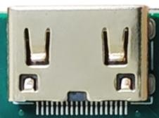
MLKPAI-FMin01 supports HDMI 720P/60FPS output.
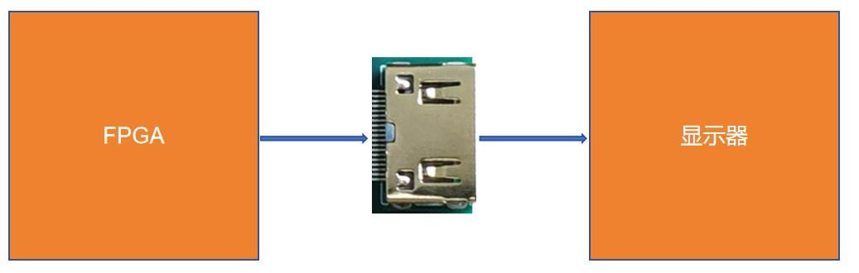
HDMI Pin Assignment Table:
Signal name | FPGA PIN | IOSTANDARD | description
B6_R1P_61 | 61 | LVCOMS33 | HDMI data differential pair P-side
B6_R1N_60 | 60 | LVCOMS33 | HDMI data differential pair N-end
B5_R2P_49 | 49 | LVCOMS33 | HDMI data differential pair P-side
B5_R2N_50 | 50 | LVCOMS33 | HDMI data differential pair N-end
B5_R1P_47 | 47 | LVCOMS33 | HDMI data differential pair P-side
B5_R1N_48 | 48 | LVCOMS33 | HDMI data differential pair N-end
B5_R3P_55 | 55 | LVCOMS33 | HDMI clock differential pair P-end
B5_R3N_54 | 54 | LVCOMS33 | HDMI clock differential pair N-end

8: TF card slot
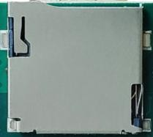
The MLKPAI-FMin01 is equipped with a TF card slot for data storage.
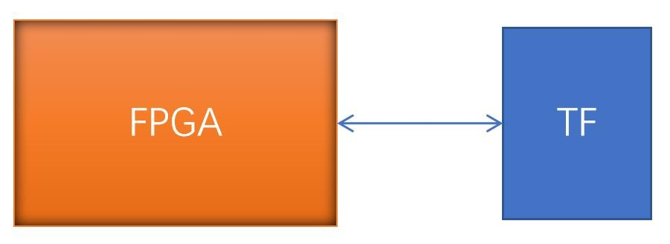
TF Pin Assignment Table:
Signal name | FPGA PIN | IOSTANDARD |  | description
B7_T5_74 | 74 | LVCOMS33 | TF card data 2
B7_T6_75 | 75 | LVCOMS33 | TF card data 3
B7_T7_76 | 76 | LVCOMS33 | TF card command
B7_T2P_78 | 78 | LVCOMS33 | TF card clock
B7_TE2N_77 | 77 | LVCOMS33 | TF card data 0
B7_T8_79 | 79 | LVCOMS33 | TF card data 1

9: EEPROM & RTC
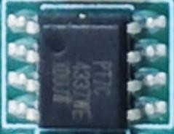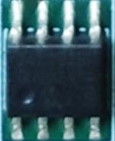
The MLKPAI-FMin01 is equipped with an EEPROM with a capacity of 2K bit and a real-time clock, both chips are mounted on the IIC bus.
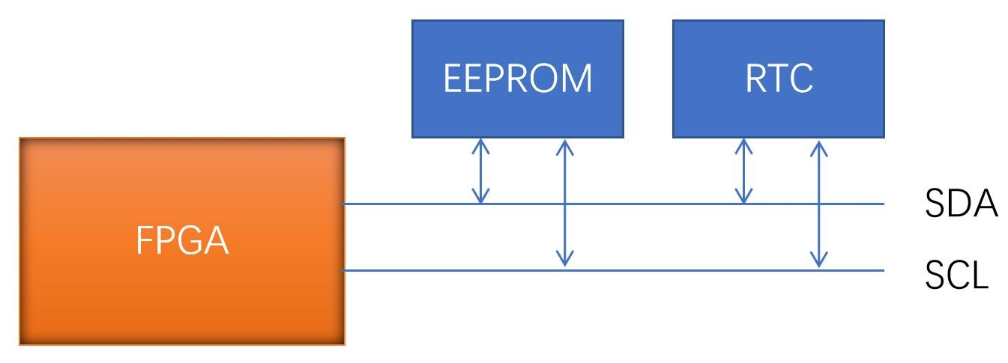
EEPROM & RTC Pin Assignment Table:
Signal name | FPGA PIN | IOSTANDARD |  | description
B4_B2_39 | 39 | LVCOMS33 | I2C data cable
B4_B3_42 | 42 | LVCOMS33 | I2C clock line

10:25MHz crystal oscillator
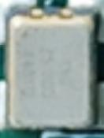
The global clock of the EG4S20NG88 is provided by an active crystal with a frequency of 25MHz.
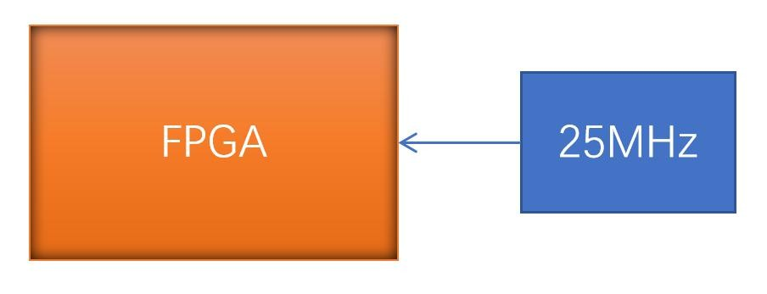
Clock Pin Assignment Table:
Signal name | FPGA PIN | IOSTANDARD |  | description
SYSCLK_25M | 34 | LVCOMS33 | Clock input

11: CEP interface
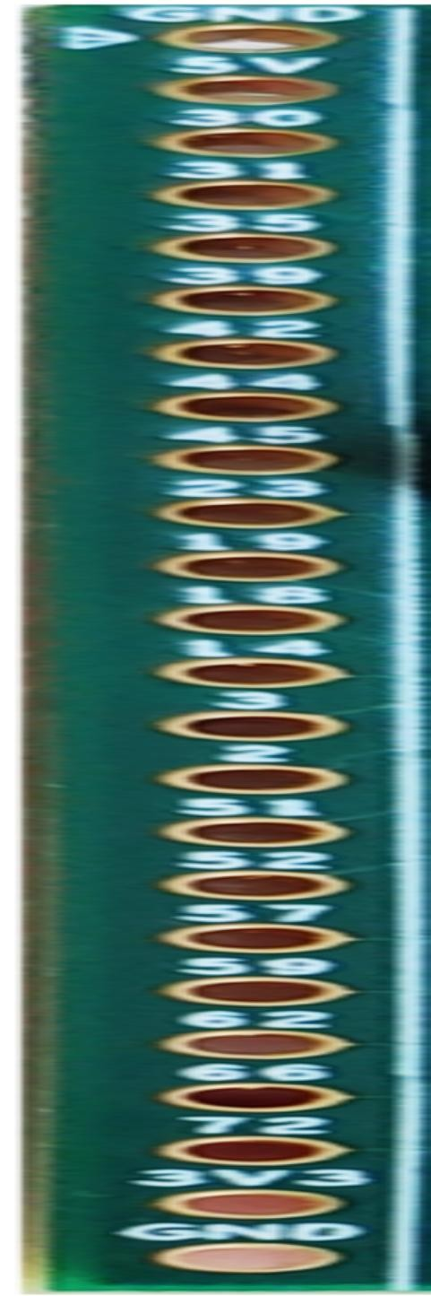
MLKPAI-FMin01 leads most of the user IO of the EG4S20NG88, and if there is a signal that is multiplexed with the rest of the functions, please refer to the IO multiplexing table.
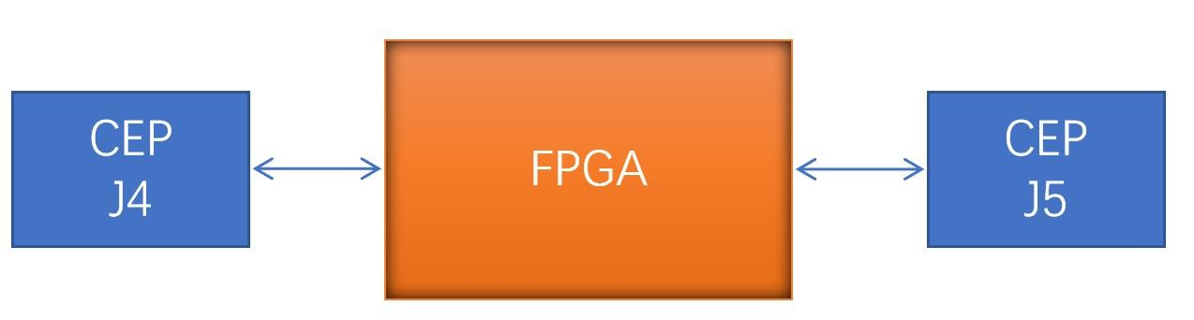
CEP Pin Assignment Table:
J4 PIN |  | FPGA PIN | J5 PIN |  | FPGA PIN
1 | GND | \ | 1 | GND | \
2 | VCC_5V | \ | 2 | VCC_5V | \
3 | B4_BE2P_41 | 41 | 3 | B3_B5_30 | 30
4 | B4_BE2N_40 | 40 | 4 | B3_B6_31 | 31
5 | B4_BE1P_37 | 37 | 5 | B4_B1_35 | 35
6 | B4_BE1N_38 | 38 | 6 | B4_B2_39 | 39
7 | B3_BE2P_32 | 32 | 7 | B4_B3_42 | 42
8 | B3_BE2N_33 | 33 | 8 | B4_B4_44 | 44
9 | B1_L3P_12 | 12 | 9 | B5_R1_45 | 45
10 | B1_L3N_13 | 13 | 10 | B3_B1_23 | 23
11 | B3_BE1P_29 | 29 | 11 | B2_L2_19 | 19
12 | B3_BE1N_28 | 28 | 12 | B2_L1_18 | 18
13 | B1_L2P_10 | 10 | 13 | B1_L4_14 | 14
14 | B1_L2N_11 | 11 | 14 | B1_L2_3 | 3
15 | B7_TE1P_70 | 70 | 15 | B1_L1_2 | 2
16 | B7_TE1N_71 | 71 | 16 | B5_R2_51 | 51
17 | B8_TE1P_86 | 86 | 17 | B5_R3_52 | 52
18 | B8_TE1N_87 | 87 | 18 | B6_R1_57 | 57
19 | B6_R2P_64 | 64 | 19 | B6_R2_59 | 59
20 | B6_R2N_63 | 63 | 20 | B6_R3_62 | 62
21 | B1_L1P_5 | 5 | 21 | B6_R4_66 | 66
22 | B1_L1N_4 | 4 | 22 | B7_T4_72 | 72
23 | VCC_3V3 | \ | 23 | VCC_3V3 | \
24 | GND | \ | 24 | GND | \

5 EG4S20NG88 IO multiplexing table
The following is a table of IO resources for reuse:
FPGA PIN |  | signal | function
2 | B1_L1_2 |  | LED6、CEP J5
3 | B1_L2_3 |  | LED5、CEP J5
4 | B1_L1N_4 |  | DVP、CEP J4
5 | B1_L1P_5 |  | DVP、CEP J4
10 | B1_L2P_10 |  | DVP、CEP J4
11 | B1_L2N_11 |  | DVP、CEP J4
12 | B1_L3P_12 |  | DVP、CEP J4
13 | B1_L3N_13 |  | DVP、CEP J4
14 | B1_L4_14 |  | LED4、CEP J4
18 | B2_L1_18 |  | DIP switch, CEP J5
19 | B2_L2_19 |  | DIP switch, CEP J5
23 | B3_B1_23 |  | DIP switch, CEP J5
28 | B3_BE1N_28 |  | DVP、CEP J4
29 | B3_BE1P_29 |  | DVP、CEP J4
30 | B3_B5_30 |  | Buttons SW3, CEP J5
31 | B3_B6_31 |  | Buttons SW2, CEP J5
32 | B3_BE2P_32 |  | DVP、CEP J4
33 | B3_BE2N_33 |  | DVP、CEP J4
37 | B4_BE1P_37 |  | DVP、CEP J4
38 | B4_BE1N_38 |  | DVP、CEP J4
39 | B4_B2_39 |  | I2C、CEP J5
40 | B4_BE2N_40 |  | DVP、CEP J4
41 | B4_BE2P_41 |  | DVP、CEP J4
42 | B4_B3_42 |  | I2C、CEP J5
45 | B5_R1_45 |  | DIP switch, CEP J5
51 | B5_R2_51 |  | LED7、CEP J5
52 | B5_R3_52 |  | LED8、CEP J5
57 | B6_R1_57 |  | LED9、CEP J5
59 | B6_R2_59 |  | LED10、CEP J5

62 | B6_R3_62 | LED11、CEP J5
63 | B6_R2N_63 | DVP、CEP J4
64 | B6_R2P_64 | DVP、CEP J4
70 | B7_TE1P_70 | DVP、CEP J4
71 | B7_TE1N_71 | DVP、CEP J4
86 | B8_TE1P_86 | DVP、CEP J4
87 | B8_TE1N_87 | DVP、CEP J4

6 Power Management
MLKPAI_FMin01 5V power supply is provided by TYPE-C, and the power-up timing of the power supply is as follows:
5
V
1.2
V
3.3
V

7 Naming conventions
Milianke hardware has a new naming convention, and for older models, the two names will be used at the same time

1: Core module naming convention
MLK – CXX - XX - XX
MILIANKEChip pin Num
Core
FamiliyChip feature Num
Num

2: Development platform naming rules
S - stands for Veneer
F-The development platform for FEP expansion interface in the form of core board + base plane
H - Development platform for FMC-HPC expansion interface in core board + backplane mode L - Development platform for FMC-LPC expansion interface for core board + backplane
MLK - XX - CXX - XX
MILIANKE
S/F/H/L
NumCore Module

